1. Create a function module to import a range of customer numbers and export the customer data for the given range.

Customer Data can be found in table KNA1.

Time : 30 minutes

Create a package and keep all objects created for this task in that package.

Paste screenshots of all the objects created for this task.

**PACKAGE: ZUST_PREM**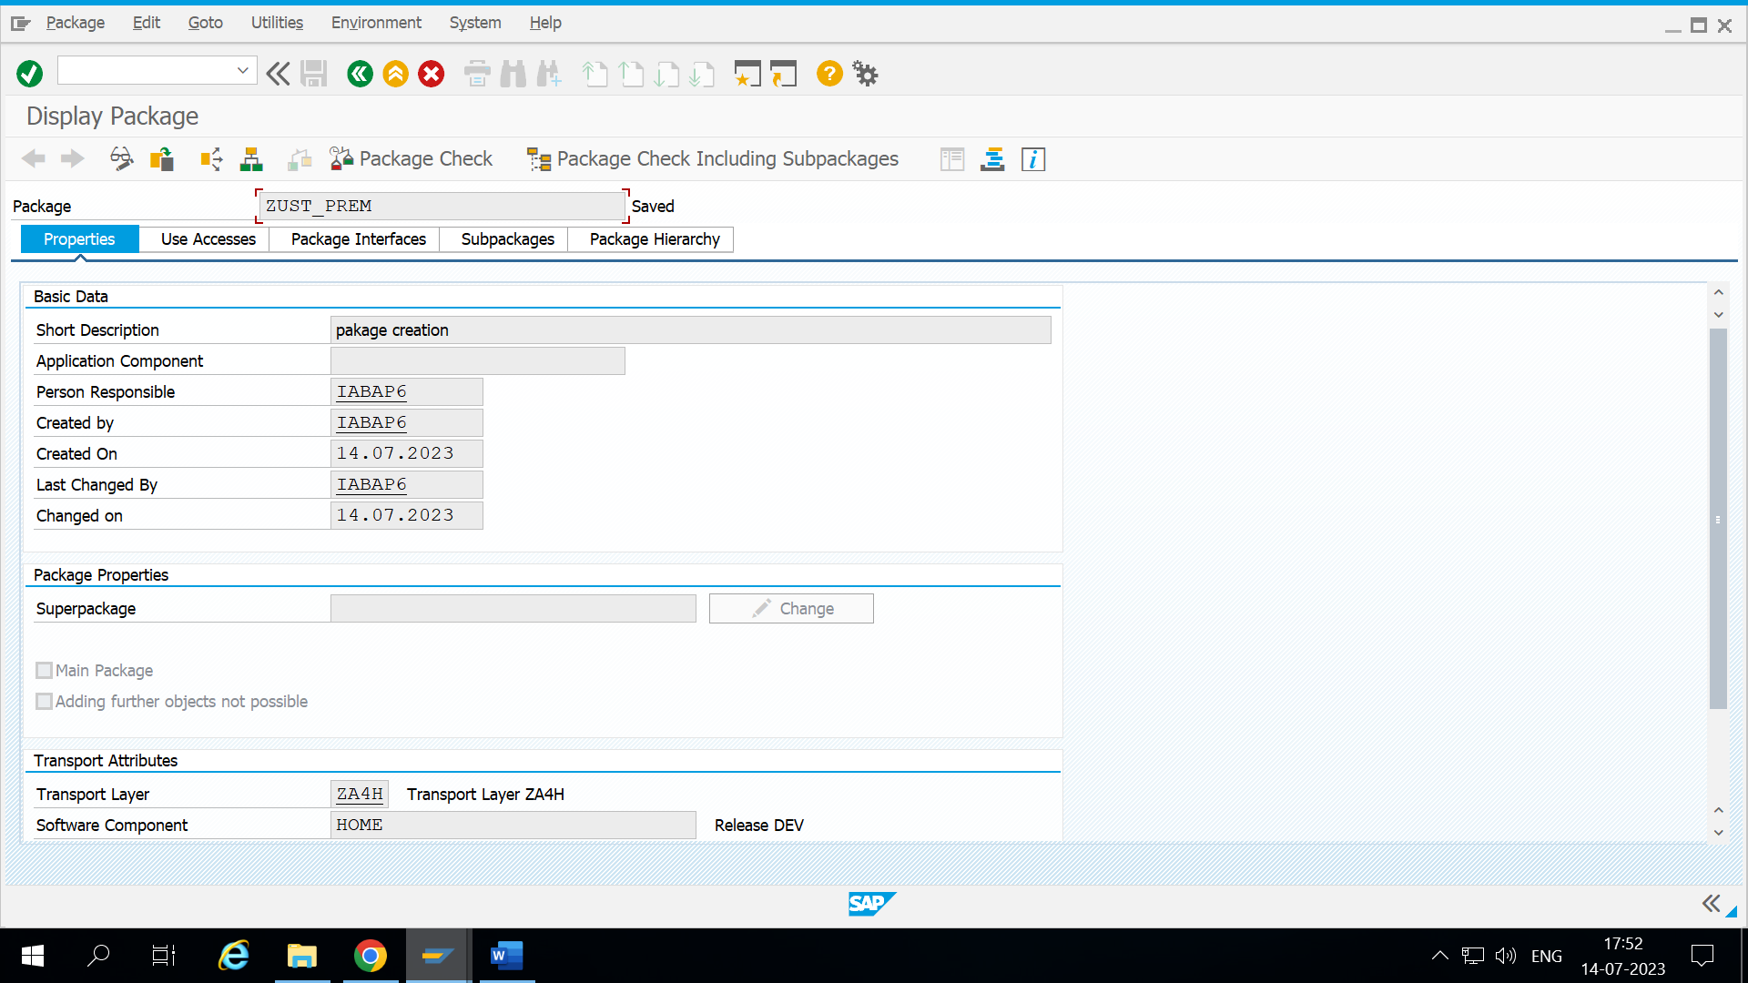

**FUNCTION MODULE: ZPREM_FNMODULE**

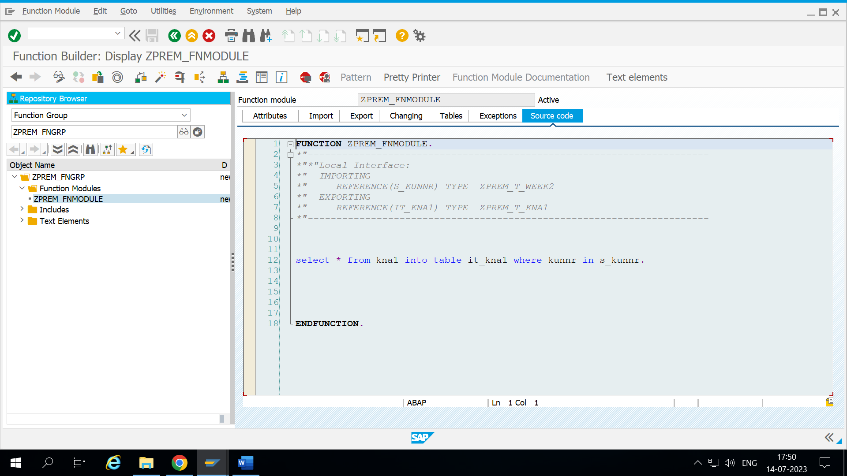

**CODE:**  ZPREM_WEEK2

*&---------------------------------------------------------------------*  
*& Report ZPREM_WEEK2  
*&---------------------------------------------------------------------*  
*&  
*&---------------------------------------------------------------------*  
REPORT ZPREM_WEEK2.  
  
data V_kunnr type kunnr.  
data itab_kna1 type Zprem_t_kna1.  
data wa_kna1 like line of itab_kna1.  
select-options s_kunnr for V_kunnr.  
perform get_det.  
perform get_dply.  
  
  
start-of-selection.  
form get_det.  
  call function 'ZPREM_FNMODULE'  
  exporting  
    s_kunnr = s_kunnr[]  
    importing  
      it_kna1 = itab_kna1.  
  
  endform.  
  
  form get_dply.  
    loop at itab_kna1 into wa_kna1.  
      write : / wa_kna1-name1,  
          wa_kna1-name2,  
          wa_kna1-land1.  
endloop.  
endform.

**OUTPUT:**

